**Introduction of railways**

the romance of train travel in India is legendary, but the task of constructing the railways in the first place was daunting. There were huge problems in dealing with such a vast and inhospitable country. The idea of introducing railways to India had been mooted as early as the 1830s (Sanyal 3). In May 1845, when the East India Company's Court of Directors finally and formally approved the project of establishing the railways in India, they also impressed upon the current Governor-General, [Lord Hardinge](http://www.victorianweb.org/sculpture/jagger/4.html), the enormity of the task, enumerating the following six reasons:

* Periodical rains and inundations.
* Continued action of violent winds and influence of a vertical sun.
* Ravages of insects and vermin.
* Destructive growth of spontaneous vegetation of underwood upon earth and brick-work.
* The unenclosed and unprotected tracts of country through which railroads would pass.
* The difficulty and expense of securing the services of competent and trustworthy engineers.

The Directors supposed, too, "that as the people of India were poor and in many parts thinly scattered over large areas passenger traffic would not be substantial" (qtd. in Sanyal 8).

[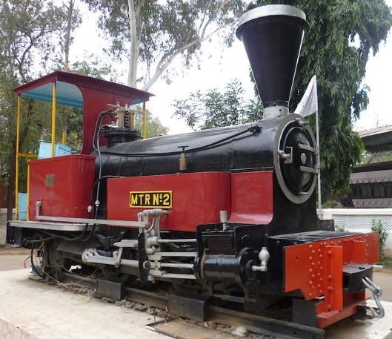](http://www.victorianweb.org/technology/railways/india/2.jpg)[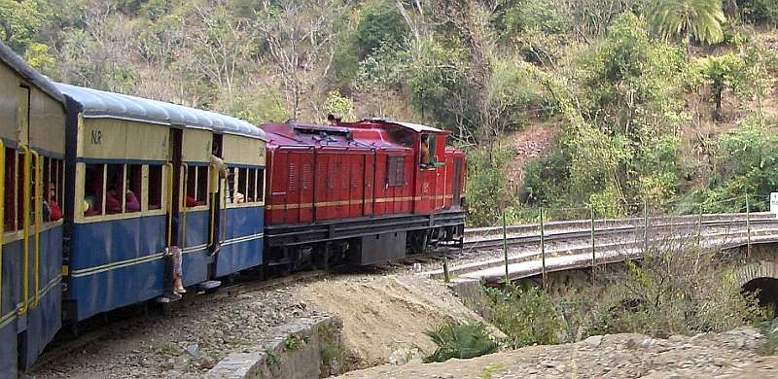](http://www.victorianweb.org/history/empire/india/4.html)

**Meaning:**

The railways have been the ‘pioneer of modern mechanical transport.’ The first Indian railway rolled on its 34 km track Mumbai to Thane on April 16, 1853. Since its beginning and up to the advent of motor transport, it enjoyed monopoly as land transport.

Railways have played a very significant role in the economic, social and political development of many countries in the world. Though the railway requires a very huge capital outlay as compared to other modes of transport, it is our principal means of transport. It carries about 70 to 80 percent of our total traffic of goods and people. The Indian railway system is the largest in Asia and the fourth largest in the world. It is also the biggest public undertaking in the country.

**Characteristics:**

**The rail transport has the following characteristics:**

**1. Public Utility Service:**

Railways provide an essential service to the public. It being a public utility service, requires protection and investments by government.

**2. Monopoly:**

Railways have monopoly in India. The rail transport is managed by the Railways Department of the Central Government. No private operator is allowed to enter this transport sector.

**3. Huge Investments:**

The railways require huge investments for purchase of land, laying of tracks, constructing railway stations and sheds, buying automobiles, etc. No single individual can afford to make all these investments.

**4. Privileges:**

The railways require special privileges to provide efficient transport service. Railways’ require special property rights for purchase of land, construction of bridges and railway lines.

**5. Special Rate Fixation:**

The railways fix separate rate for passengers and goods traffic. The same rates are applicable to all persons and all areas of the country. Rail services are available to all members or the public on equal terms.

**6. Non-transferability:**

Once the railway lines are laid down then these tracks cannot be used for any other purpose. So railway services are non- transferable.

# Features

Our editorial board comprises a specialist group of leading industry figures who, in conjunction with the railway technology editorial team, identify the main drivers of the industry helping to produce regular, thought provoking opinion pieces on the latest issues, challenges and developments.

## Latest Railway Feature

[](http://www.railway-technology.com/features/featurethe-big-stink-how-much-do-trains-really-emit-4807131/)

# Application Form For Railway Recruitment Board 2016

Application Form For Railway Recruitment Board 2016 – Welcome to the Section for Form Download at FindForm.in. The Section will help you find out the latest announced Application Form For Railway Recruitment Board for Exam. Application or form is very first part to be eligible for applying and thus you need to pay attention while feeling it. There are high chances of rejection if Application Form For Railway Recruitment Board has not filled properly with all required detail. In that case you will be losing money you paid for buying form

Here at FindForm.in we will be helping you how to fill Application Form For Railway Recruitment Board. Below is some instruction which helps you to download the form and Fill it in right manner so, you can avoid rejection. Once you download and dully filled the form please go ahead and send Application Form For Railway Recruitment Board to related department or person to make sure your application counted

**Below is Instruction how to download Application Form For Railway Recruitment Board**

* Visit official website for Application Form For Railway Recruitment Board Section
* Find form Link from its Official Website
* Download Application Form For Railway Recruitment Board and print it
* Fill up and attached documents required
* Scan or submit it in exam center or email

Best of Luck for Exam for your